Customize template

1. 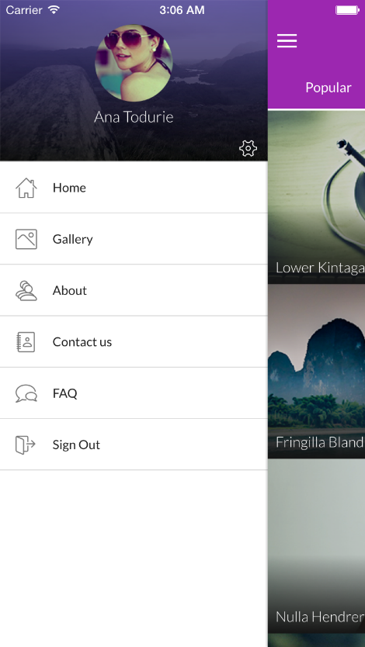How to customize side menu.

You have to go in Menu.HTML and refer to the below mentioned codes

<ion-list class="side-menu">

<ion-item nav-clear menu-close href="#/app/home" class="item-icon-left">

<i class="icon ln-home3 side-menu-i"></i>

Home

</ion-item>

<ion-item nav-clear menu-close href="#/app/gallery" class="item-icon-left">

<i class="icon ln-picture side-menu-i"></i>

Gallery

</ion-item>

<ion-item nav-clear menu-close href="#/app/about" class="item-icon-left">

<i class="icon ln-users side-menu-i"></i>

About

</ion-item>

<ion-item nav-clear menu-close href="#/app/contact" class="item-icon-left">

<i class="icon ln-contacts side-menu-i"></i>

Contact

</ion-item>

<ion-item nav-clear menu-close href="#/app/faq" class="item-icon-left" ng-click="share();">

<i class="icon ln-comments side-menu-i"></i>

FAQ

</ion-item>

<ion-item nav-clear menu-close href="#/user-login" class="item-icon-left" ng-click="logout()">

<i class="icon ln-exit side-menu-i"></i>

Sign Out

</ion-item>

</ion-list>

1. How to customize the Gallery page.

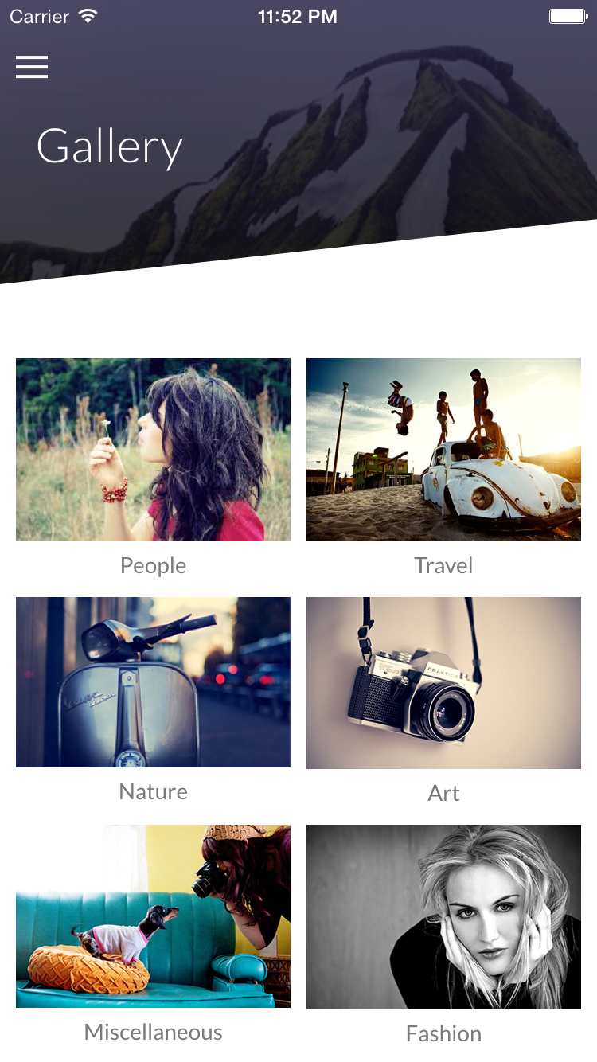

Go to controller.js file in JS folder. Or find gallery controller (GalleryCtrl) and change to name and image source.

$scope.gallery = [{

id: 1,

imagename: "People",

imgpath: "img/gallery/demo500x313.png"

}, {

id: 2,

imagename: "Travel",

imgpath: "img/gallery/demo500x313.png"

}, {

id: 3,

imagename: "Nature",

imgpath: "img/gallery/demo500x313.png"

}, {

id: 4,

imagename: "Art",

imgpath: "img/gallery/demo500x313.png"

}, {

id: 5,

imagename: "Miscellaneous",

imgpath: "img/gallery/demo500x313.png"

}, {

id: 6,

imagename: "Fashion",

imgpath: "img/gallery/demo500x313.png"

}, {

id: 7,

imagename: "Business",

imgpath: "img/gallery/demo500x313.png"

}];

1. How to define variables in SCSS and change color

Firstly, you have to go in the Selig folder

And run the below mentioned CMD and keep the window on throughout, till the time you are done with working on the SCSS file.

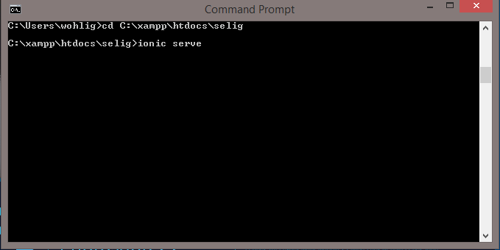

How to define and change variable and CSS in SCSS file.

Go in 🡪 path (lib\selig\scss) and open the selig.scss file.

And define the variable as you want.

$positive: #9C27B0 !default;

$calm: #03A9F4 !default;

$stable: transparent !default;

$base-color: #212121 !default;

And CSS also.

.login-set {

margin-top: 10%;

text-align: center;

}

If you want to define your own CSS, you can do it on style.css.